Lithium-Ion Battery Single Particle Model Tutorial

Lithium-Ion Battery Single Particle Model is the code to simulate the lithium-ion battery cell model.

The code contains various models.

1. Finite Difference Method Model without Degradation. (FDM Model)
2. Finite Difference Method Model with Linearized Degradation. (FDM LM Model)
3. Finite Difference Method Model with Nonlinear Degradation. (FDM NM Model)
4. Pade Approximation Model without Degradation (Pade Model)
5. Pade Approximation Model with Degradation (Pade-D Model)
6. Optimization-Based Model (O-B Model)
7. Diagram

   Description automatically generatedSimulink (Open “battery_cell_model.slx”)

Capacity Loss

Side reaction current density

Positive

Surface Concentration

Negative

Surface Concentration

Voltage

O-B Model

Pade-D Model

Pade Model

FDM NM Model

FDM LM Model

FDM Model

Battery Cell

Output Voltage

Capacity Loss

Positive Electrode

Negative Electrode

Negative Electrode

Side reaction current density

Output equation of the state space model.

Calculate the surface concentration

State equation

Positive Electrode

Output equation of the state space model.

Calculate the surface concentration

State equation

1. MATLAB File

To run the code, open the file “RUN_ROM_battery_cell.m”

Following steps are the setup to run the battery cell model.

1. Text, chat or text message

   Description automatically generatedYou have to choose what model you are going to run. (FDM Model, FDM_LM Model, FDM_NM Model etc.)
2. After you choose the battery cell model, you have to select what parameters you are going to use. Skip this part if you select the model that does not contain a degradation model

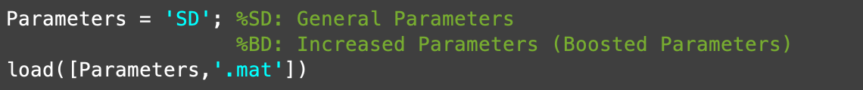In this code, we have two options. First is ‘SD’ (General Parameters). Second is ‘BD’ (Increased Parameters)

1. Select the model’s order

FDM Model & FDM LM Model

FDM NM Model

In FDM NM Model, we have to load the nonlinear map to calculate the negative surface concentration. There are two nonlinear maps. 'degradation_map_SD.mat' is for ‘SD’. 'degradation_map_BD.mat' is for ‘BD’.

Pade Model & Pade-D Model

O-B Model

1. Setup the input current

If you want to use the 1-D look up table block you have to setup the ‘t’ and ‘u’ variables.

Or you can setup the various input current using Simulink block as shown above. (Sinusoid wave, square wave etc.)

1. Initial Condition

In initial condition part, the only thing you have to change is “line 137”.

1. Linearized side reaction current density coefficients (minor step)

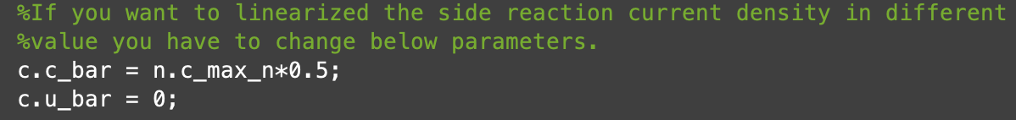

Remind below equation.

Line 174 – Line 197 is the code to calculate the .

1. Text

   Description automatically generatedSetup the time range.